MCDA5570

E-Commerce Big Data Project

Mohd Nawaz Hussain - A00428036

Caner Adil Irfanoglu – A00425840

Gaganpreet Singh – A00429660

Vinay Govindan – A00429120

Sunil Padikar – A00428089

Table of Contents

Executive Summary 2

Description of Data 3

Exploratory Analysis from Tableau Via Hive 4

Connection of Apache Hive to Tableau 4

Items Generating Most Revenue 5

Most Sold Items 6

Most Frequent Buyers 6

Busiest Months 7

Top 10 Revenue Generating Buyers 8

Technologies Used 9

HDFS 9

APACHE HIVE 9

TABLEAU 9

APACHE PySpark 9

Apache MLlib 11

FEATURE ENGINEERING 12

Elbow Plot 13

Results 14

3-D Buyer Cluster Visualization 14

Discussion/ Conclusion 15

Additional Feedback 16

Difficulties Faced 16

Easily understandable topics 16

Group Verdict of the Course 16

# Executive Summary

The purpose of this report is to describe our analysis on E-Commerce Dataset using Hadoop technologies.

We started with exploratory analysis to get a better understanding of the order and item datasets. This is done via pipelining Hive with Tableau. This part provided us insight about the orders and buyers’ behavior separately. We obtained the best of these categories in terms of the revenue generated as well as the frequency of the buyers.

Next, PySpark is used for transforming the data. 2 datasets are first read from HDFS, cleaned and then joined for the customer segmentation analysis. After the transformation, we obtained ‘Recency’, ‘Frequency’ and ‘Profit’ information. We clustered the buyers based on the RFM variables. Finally, we appended the cluster labels to the orders dataset. This provided us the distribution of customer categories across orders.

All in all, this project provided the group insight about the customer behavior in E-Commerce Business. Also, it helped gaining hands on experience with the big data technologies such as, HDFS, Hive, PySpark, PySpark-mllib and Apache Zeppelin.

# Description of Data

E-Commerce dataset is consisted of two text files. First file is ‘os_order.txt’ contains general information about orders between April 2010 to December 2011. The columns have buyer, date, location (IP Address) and status related information. Second file is ‘os_order_items.txt’ which contains more granular information about the details of every transaction. We can access individual item ID’s in each transaction alongside with buying price and retail price with the quantities. Datasets are merged using order id’s when necessary through the analysis. Unofficial metadata is as follows:

**OS_ORDER**

1. **ORDER_ID:** Unique order id
2. **ORDER_CODE:** 12 digit unique order code
3. **BUYER_ID:** 5 digit unique number assigned to buyer
4. **PAY_DT:** ‘yyyy-mm-dd HH:MM:SS’ formatted date for time of transaction
5. **CREATE_IP:** IP Address where the order is placed from
6. **ORDER_STATUS:** Status information takes values between 1-9, A, B, z

**OS_ORDER_ITEM**

1. **ITEM_ID:** Unique index number for the purchased item
2. **ORDER_ID:** Unique order id
3. **GOODS_ID:** 7 digit unique item id of the purchased item
4. **GOODS_NUMBER:** Quantity of the purchased item
5. **SHOP_PRICE:** Retail price of the item
6. **GOODS_PRICE:** Wholesale price of the item for the company
7. **GOODS_AMOUNT:** Revenue generated from the transaction

# Exploratory Analysis from Tableau Via Hive

## Connection of Apache Hive to Tableau

We connected to Tableau through Apache Hadoop Hive using the ODBC (Other Databases) connector provided by Tableau. The third-party driver used was Hortonworks ODBC driver for Apache Hive.



Figure . Connecting Tableau to Apache Hadoop using ODBC.

## Items Generating Most Revenue

For our analysis of the e-commerce data, one of the most pertinent factors in understanding the business and sales functionality of the corporation is revenue. From Tableau, we found that the item generating the most revenue is marked by ‘Goods ID 1017025’. This item encompasses $8,491.50K of sales the company has had in our dataset. The next highest item in our list is marked by ‘Goods ID 1016265’ generating $1,490K.



Figure . Items generating the most revenue.

## Most Sold Items

Based on the pricing of an item, the most sold item does not necessarily have to be the item generating the most revenue. By running our analysis on the dataset, we have found the item with ‘Goods ID 1014040’ with approximately 33.33K units sold. The second most sold item is ‘Goods_ID 1015320’, selling approximately 23.91K units.



Figure . Most sold items.

## Most Frequent Buyers

We grouped the data with the buyer’s ID to see which buyers had been the most frequent in the e-commerce website. The buyer with the most orders was Buyer ID 10023 who had ordered from the website 204 times in total. While the second most frequent buyer was Buyer ID 33961 who ordered a total of 160 times from the website.



Figure . Most frequent buyers.

## Busiest Months

From the analysis, we can see the busiest monthly period was from June– December 2011. The peak period in number of orders was in the month of November, 2011 with 4,396 orders. There is a gradual slump from the month of June 2010 until September 2010 and then continues to gradually increase in number of orders until accelerating the most between July and August 2011.



Figure . Months by Orders.

## Top 10 Revenue Generating Buyers

We generated the most revenue generating customers from our dataset and realized an outlier existed. This consumer (Buyer ID 36081) was significantly more invested than any of the other buyers and was a clear outlier. We removed the outlier and proceeded to regenerate our graph to show the buyer’s generating the most revenue. The buyer with the most revenue is Buyer ID 9005 who has generated $195.97K.



Figure . Top 10 Buyers before outlier removal.



Figure . Top 10 Buyers after outlier removal.

# Technologies Used

## HDFS

It is used to store the store the dataset. Data has been transferred from SMU dev server to Hadoop distributed file system using following commands.

df_order = spark.read.option("delimiter", "\\t").option("header", "true").csv("/user/root/OS_ORDER.txt")

df_item = spark.read.option("delimiter", "\\t").option("header", "true").csv("/user/root/OS_ORDER_ITEMS.txt")

## APACHE HIVE

We imported the datasets from PySpark dataframe to apache Hive. We queried the tables to get the initial overview of the data.

df_order.write.mode("overwrite").saveAsTable("df_order")

df_item.write.mode("overwrite").saveAsTable("df_item")

## TABLEAU

Tableau is used for exploratory data analysis. We setup a server connection between Tableau and Apache Hive using Hortonworks Hadoop Hive server and then visualized the data to answer below questions:

* Most frequent buyer
* Products generating most revenue
* Buyers generating the most revenue
* Trend of orders over month

## APACHE PySpark

We have used Apache PySpark library for data cleaning and data preparation. Following task has been done using PySpark:

* Data has been imported from HDFS to Spark dataframe

df_order = spark.read.option("delimiter", "\\t").option("header", "true").csv("/user/root/OS_ORDER.txt")

df_item = spark.read.option("delimiter", "\\t").option("header", "true").csv("/user/root/OS_ORDER_ITEMS.txt")

* Data has been imported to Apache Hive for querying

df_order.write.mode("overwrite").saveAsTable("df_order")

#df_item.write.mode("overwrite").saveAsTable("df_item")

* Extra columns have been dropped and rows containing NULL values are removed

df_order = df_order.drop(*['CREATE_DT', 'EXCEPTION_STATUS'])

df_order_noNA = df_order.where(df_order.PAY_DT != 'NULL')

* Both the datafames are merged based on ORDER_ID

df_combined = df_order.join(df_item,[df_order_noNA.ORDER_ID == df_item.ORDER_ID])

## Apache MLlib

We have used the Apache MLlib library to perform Unsupervised machine learning i.e. K-Means clustering on our dataset.

* We started with finding the optimal number of clusters based sum of square of distance and plotted elbow curve through which we found 5 clusters to be optimal.
* Then we performed k-means clustering with k= 5 clusters based on Profit, recency and order_count
* After that, we appended clusters numbers generated by k-means clustering to our existing dataframe

assembler=VectorAssembler(inputCols=["PROFIT","RECENCY","ORDER_COUNT"], outputCol="features")

# FEATURE ENGINEERING

* New column has been derived by extracting “mm-yyyy” from PAY_DT
* Profit column has been created based on shop_price, goods_price and goods_number

df_profit = df_combined.withColumn('profit', (df_combined.SHOP_PRICE - df_combined.GOODS_PRICE)*df_combined.GOODS_NUMBER)

* Recency of the orders are created by subtracting the order date from most recent order date
* RFM has been calculated for each buyer
* Joining dataframes together to perform Unsupervised machine learning

df = assembler.transform(df_combined_final_kmeans)

kmeans = KMeans().setK(5).setSeed(1L)

model = kmeans.fit(df)

# Results of clustering

results = model.transform(df)

results.show(2)

# Evaluate clustering by computing Silhouette score

evaluator = ClusteringEvaluator()

silhouette = evaluator.evaluate(results)

# Shows the result.

centers = model.clusterCenters()

print("Cluster Centers: ")

for center in centers:

## Elbow Plot

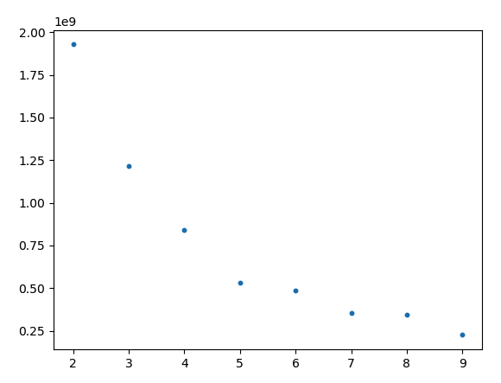

Figure 8: Elbow Plot for deciding optimal number of clusters

Optimal Number of Clusters are found as 5.

# Results

## 3-D Buyer Cluster Visualization

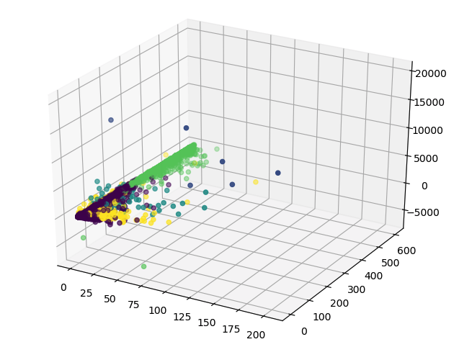

Figure 9: 3D Visualization of RFM variables colored by clusters

We can see above the 5 different clusters representing the data in different colors in three dimensions. We plotted the results to show the most popular clusters in terms of number of order for each segment of the cluster.

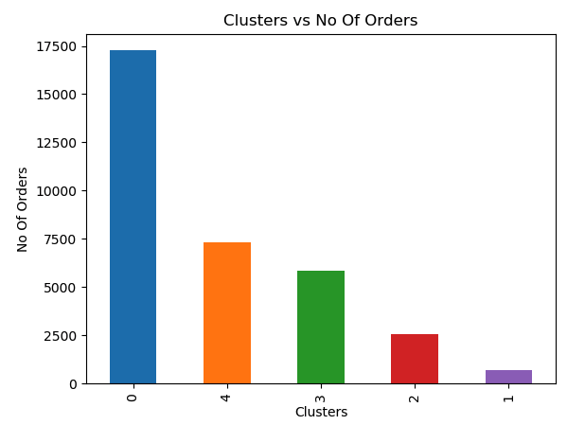

Figure 9: Total Number of Orders for customer segments

# Discussion/ Conclusion

We started our analysis by examining the orders and buyer’s behaviour separately. We obtained the best of these categories in terms of the revenue generated as well as the frequency of the buyers. We found that 3.2% of orders placed by top 10 buyers.

We then continued our analysis plotting the total number of orders over months. This provided us insight about how customer behaviour changed over time. It is found that the business is booming during the 4th Quarter of the year.

To decide, if this is the result of seasonality or just the increased popularity of business, we would require more data from different years. Lastly, ‘Recency’, ‘Frequency’ and ‘Monetary’ (profit) data is extracted for customer segmentation. Unsupervised Machine Learning is applied for clustering the customers into different categories. In total, it is found that 5 separate clusters represent different groups of customers best in terms of minimized error term. Also, we found that almost half of the orders fall into the cluster 0, which corresponds to the orders mostly with 0% profit margin. Remaning orders split between other 4 groups, where cluster 1 corresponds to small number of orders returning the most profits.

To conclude, this project allowed us to make use of multiple technologies provided by Apache. The project allowed us to demonstrate our knowledge, skill and aptitude in using the various technologies taught to us by Mr. Nikita Neveditsin.

# Additional Feedback

## Difficulties Faced

In general, we had to work with lower level API’s in Hadoop Ecosystem. The complexity of the distribution system introduces additional challenges. We had difficulty understanding how map-reduce exactly works. Simple data transformation and ingestion tasks required significant effort from time to time. Lastly, integrating multiple technologies was a challenge but instructive task.

## Easily understandable topics

Understanding working with the tools designed to provide conventional work flows was relatively easy. For example, Hive uses similar syntax to conventional SQL structure. Zeppelin uses the modern notebook style development interface, which is versatile and easy to follow. Accompanying, Hadoop Ecosystem and different tools with the Linux classes made it more comfortable working with several different tools using Terminal interface.

## Group Verdict of the Course

Managing Information Tech & Systems 5570 is in general a very successful hybrid course bringing management and IT aspects together. The Linux and Hadoop classes were instructive enough but still provided a lot of valuable hands-on experience.